


Standards and Assessment Guide

IT Software Solutions for

Business

v1.0
©WorldSkills International

Introduction
Welcome to the Standards and Assessment Guide (SAG), a comprehensive resource designed to support excellence in assessment practices for all skills competitions hosted at the WorldSkills Competition. A key component of the SAG is the commitment to continuous improvement through ongoing review, ensuring that these guides consistently reflect the latest industry innovations and high standards of assessment in an open and transparent manner.

Purpose
The primary purpose of this guide is to provide a structured framework for the consistent and fair assessment of each skill competition. It aims to ensure that all assessments are conducted with a high degree of accuracy, reliability, and validity, and reflect global industry standards. By adhering to these guidelines, assessors can maintain the integrity of the competition and uphold the high standards associated with WorldSkills.

Note: this guide is not a replacement for the Marking Scheme and should only be used as a reference when required during the assessment process. Competitors are not allowed to have a copy of this SAG in the workshop in either digital or paper form.

Scope
This document covers general assessment practices applicable to a diverse range of industry sectors including:
- Manufacturing and Engineering Technology
- Information and Communication Technology
- Construction and Building Technology
- Transportation and Logistics
- Social and Personal Services
- Creative Arts and Fashion
Each skill competition has its unique requirements and benchmarks, which are detailed within sections of this guide. The consistency of assessment across each skill is the overarching principle, ensuring a unified approach to evaluating Competitor performance to the highest standards.

Key Components
The guide is structured into several key components, each addressing critical aspects of the assessment process:

Assessment Principles and Objectives
  - Emphasis on fairness, transparency, and objectivity in assessments.
  - Alignment with global industry standards and best practices.

Assessment Methods and Tools
  - Description of various assessment methods in Measurement and Judgement
  - Guidance on the application of appropriate assessment tools and equipment (if applicable).

Criteria and Benchmarks
  - Examples of assessment criteria and aspects for each skill, outlining the expected competencies and performance standards.
  - Benchmarks for different levels of proficiency i.e. Judgement award range 0, 1, 2, 3 or Yes / No criteria alongside clear measurable descriptors.

Expert assessment requirements
  - Completion of the Access Programme
  - Approved Curriculum Vitae (CV)
  - Reaching 100% Expert preparedness
  - Full participation of online and in-person Mandatory Assessment Training (MAT)
  - Completion of practical assessment testing at the Competition

Quality Assurance and Improvement
  - Mechanisms for monitoring and evaluating the assessment process.
  - Strategies for continuous improvement and feedback incorporation.
  - Ongoing periodic review of the assessment process

Implementation
For effective implementation, this guide should be used for guidance purposes only and in parallel with the Technical Description for each skill. Experts are encouraged to familiarize themselves thoroughly with both the general guidelines and the particular requirements of their respective skill areas. Collaborative efforts between the Skill Management Team, Experts, and Competitors are vital for achieving the ultimate goal of global skills development.

Conclusion
The Standards and Assessment Guide embodies the commitment of the WorldSkills movement to nurturing talent and promoting the highest standards of vocational education and training worldwide. By providing clear and comprehensive guidance, we aim to empower Experts to conduct marking and assessment practices that are not only rigorous and equitable but also inspiring and transformative for all participants.
Thank you for your dedication to upholding these standards and contributing to the success of the WorldSkills Competition. Together, we can continue to champion skills excellence and celebrate the achievements of talented individuals from around the globe.

Skill 09 – IT Software Solutions for Business
Measurement
Measurement is used to assess accuracy, precision, and other performance that can be measured objectively. It is used where ambiguity must be avoided. The total marks allocated to measurement marking may vary from competition to competition depending on the Test Project.

1 | Work Organization and Management
2 | Communication and Interpersonal Skills
3 | Problem Solving, Innovation and Creativity
4 | Analysis, Design and Software Solutions
5 | Development and Software Solutions
6 | Testing Software Solutions

Aspect | WSOS section as per TD | Descriptor
1 | Work Organization and Management | - Plan each day’s production schedule according to available time and take into account time limitations and deadlines  - Apply research techniques and skills to keep up-to-date with the latest industry guidelines  - Review own performance against the expectations and needs of clients and organizations  - Work within the sustainability guidelines expected by the clients and organizations
2 | Communication and Interpersonal Skills | - Use literacy skills to:  - Follow documented instructions from supplied guides  - Interpret workplace instructions and other technical documents  - Interpret and understand systems specification documents  - Keep up-to-date with latest industry guidelines  - Use oral communication skills to:  - Discuss and offer suggestions regarding system specifications  - Keep clients updated regarding systems’ progress  - Negotiate with clients regarding project budgets and timelines  - Gather and confirm clients’ requirements  - Present proposed and final software solutions  - Use written communications skills to:  - Documents and demonstrates solutions by developing  documentation, flowcharts, layouts, diagrams, charts, code comments and clear code.  - Keep clients updated regarding systems’ progress  - Confirm that created applications meet original specifications and obtain user sign-off for completed systems  - Use team communication skills to:  - Collaborate with others to develop required outcomes  - Contribute to group problem solving  - Use project management skills to:  - Prioritize and schedule tasks  - Allocate resources to tasks

Aspect | WSOS section as per TD | Descriptor
3 | Problem Solving, Innovation and Creativity | - Use analytical skills to:  - Synthesize complex or diverse information  - Determine the functional and non-functional requirements of specifications  - Use investigation and learning skills to:  - Obtain user requirements (e.g. interviews, questionnaire,  document search and analysis, joint application design, and observation)  - Research encountered problems independently  - Use problem-solving skills to:  - Identify and resolve problems in a timely manner  - Gather and analyse information skilfully  - Develop alternatives for decision making, select the most appropriate alternatives and produce the required solutions  - Develop business logic and computational algorithms for specific tasks

Aspect | WSOS section as per TD | Descriptor
4 | Analysis, Design and Software Solutions | - Analyse systems using:  - Use Case modelling and analysis (e.g. Use Case Diagram, Use Case Description, Actor Description, Use Case Package)  - Data modelling tools and techniques (e.g. Entity Relationship Diagram, Normalization, Data Dictionary)  - Structural modelling and analysis (e.g. Object, Class, Domain Class Diagram)  - Dynamic modelling and analysis (e.g. Sequence Diagram, State Diagram, Activity Diagram)  - Design systems using:  - C4 Model: System Context – Container – Component Diagram and System Landscape Diagram  - Wireframe for UI and UX concepts  - Application Interface (API)  - Relational database design  - Security and controls design
5 | Development and Software Solutions | - Develop software solutions by studying information needs, conferring with users, and studying systems flow, data usage, and work processes  - Use database management systems to construct, store and manage the data for the required systems  - Use latest software development environments and tools to modify existing codes and write new codes of client-server-based software solutions  - Evaluate and integrate appropriate libraries and frameworks into the software solutions  - Build multi-tier applications  - Construct Native Windows-based or Native Android-based interfaces (Using Native Development Technology or Cross-platform Technology) for client- server-based systems

Aspect | WSOS section as per TD | Descriptor
6 | Testing Software Solutions | - Plan testing activities (e.g. unit testing, volume testing, integration testing, and acceptance testing)  - Design test cases with data and check results of test cases  - The implementation of black and white box testing

Measurement:
Criteria A: Work organization and management

Criteria ID | Sub Criteria | Aspect Description | Extra Aspect Description | Score | Max Marks | Competitor work: (after demonstration)
A1 | Session 1- Correct delivery of all tasks | Proper time and work management that results in correct delivery of all requested forms or tabs | - Deduct 0.5 for all the requests are not fulfilled  - Deduct 0.25 if  each missing deliverable | 0.25 | 1 | - 4 out of 5 main tasks UI workflow is correctly.  - 2 out of 5 tasks requirement is not completely fulfilled
 |  | M

ANSWER: The Competitor has Scored (0.25)

The main five tasks of the session 1 including “Login”, “Forget Password”, “Main Menu”, “User Profile update”, “Logout” Demonstration found:
- the workflow of “Login”, “Forget Password”, “Main Menu”, “Logout” and correctly show the correct workflow and missing “User Profile update” UI. (deduct 0.25)
- Therefore, not all request fulfilled (deduct 0.5)
- Functional requirements, such as “the message should be displayed while login failed”, should not be marked in this criterion.

Criteria B: Communication and interpersonal skills

Criteria  ID | Sub Criteria | Aspect Description | Extra Aspect  Description | Score | Max  Marks | Competitor work: (after demonstration)
B1 | Session 1- Correct understanding of all tasks | Proper understanding of the technical documentation and application structure | - Full marks if all sections are understood  - Deduct 0.2 if less than 50% of sections are not shown to be comprehended | 1 | 1 | - 4 out of 5 main tasks UI workflow is correctly.  - Over 50% of the measurement description in other criteria has been fulfilled.
 |  | M

ANSWER: The Competitor has Scored (1)

The main five tasks of the session 1 including “Login”, “Forget Password”, “Main Menu”, “User Profile update”, “Logout”
- the workflow of “Login”, “Forget Password”, “Main Menu”, “Logout” and correctly show the correct workflow and missing “User Profile update” UI.
- Functional requirement “the message should be displayed while login failed” did not work properly. However, this is 1 of the 10 functional requirements of the login screen.

Criteria C: Problem solving, innovation, and creativity

Criteria ID | Sub Criteria | Aspect Description | Extra Aspect Description | Score | Max Marks | Competitor work: (after demonstration)
C1 | Session 5- Problem Solving in Bilingual interface design | The menu is displayed after launching the application, user can switch the languages of the UI by selecting the designated language. | - Add 0.25 if using a radio button or dropdown menu to select language  - Add 0.25 if the language can be changed correctly to selected language | 0.5 | 0.5 | 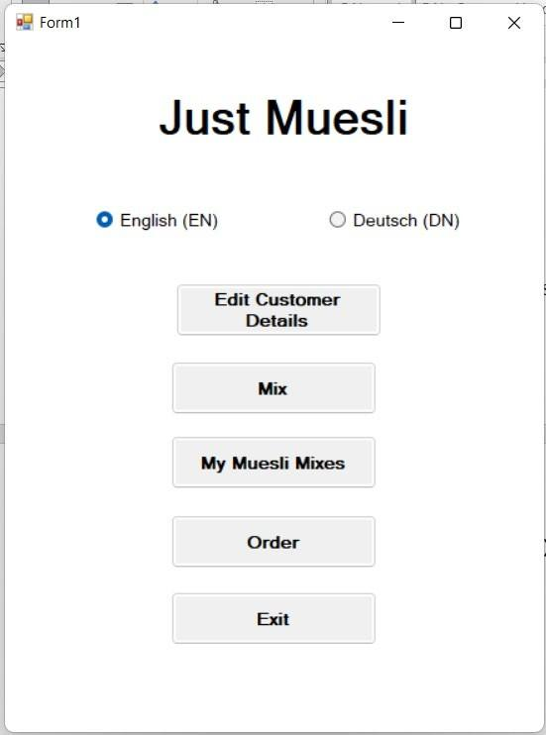
 |  | M

ANSWER: The Competitor has Scored (0.5)
- Competitor implemented the language selection feature with a radio button
- The interface can change to Deutsch once selected “Deutsch (DN) and it can change to English once selected “English (EN)

Criteria D: Analysing and designing software solutions

Criteria  ID | Sub  Criteria | Aspect Description | Extra Aspect  Description | Score | Max  Marks | Competitor work: (after demonstration)
D1 | Session 1- Acceptable analysis and perception of the directives | There are clear signs that the solution confirms to what has been intended | - Deduct 0.5 for lack of understanding of the database  - Deduct 0.5 for lack of understanding of app structure | 1.9 | 2.5 | - 4 out of 5 main tasks UI workflow is correctly.  - Over 50% of the measurement description in other criteria has been fulfilled.
 |  |  | - Deduct 0.1 for each missing form or page
 |  |  | - Add 0.5 if less than 50% variance to the instructions
 |  | M

ANSWER: The Competitor has Scored (1.9)

The main five tasks of the session 1 including “Login”, “Forget Password”, “Main Menu”, “User Profile update”, “Logout”
- the workflow of “Login”, “Forget Password”, “Main Menu”, “Logout” and correctly show the correct workflow and missing “User Profile update” UI. (Deduct 0.1)
- the login feature did not connect to the database. It only login based on a user not existed in the database. (Deduct 0.5)

Criteria E Development of Software Solutions

Criteria  ID | Sub  Criteria | Aspect Description | Extra Aspect  Description | Score | Max  Marks | Competitor work: (after demonstration)
E4 | Ordering summary preview | The Order should show quantity, Shipping Cost, Taxes and the Grand Total. Selected items and quantity entered displayed correctly and grand total is calculated correctly. | - Add 0.2 if quantity is displayed  - Add 0.2 if shipping cost is displayed  - Add 0.2 if corresponding tax is displayed correctly  - Add 0.2 if grand total is displayed  - Add 0.5 if selected items with corresponding unit price and quantity are displayed correctly  - Add 0.2 if Back to Menu and Submit buttons are displayed  - Add 0.5 if Grand total calculated correctly  - Deduct 0.1 for each item not related displayed | 1.7 | 2 | 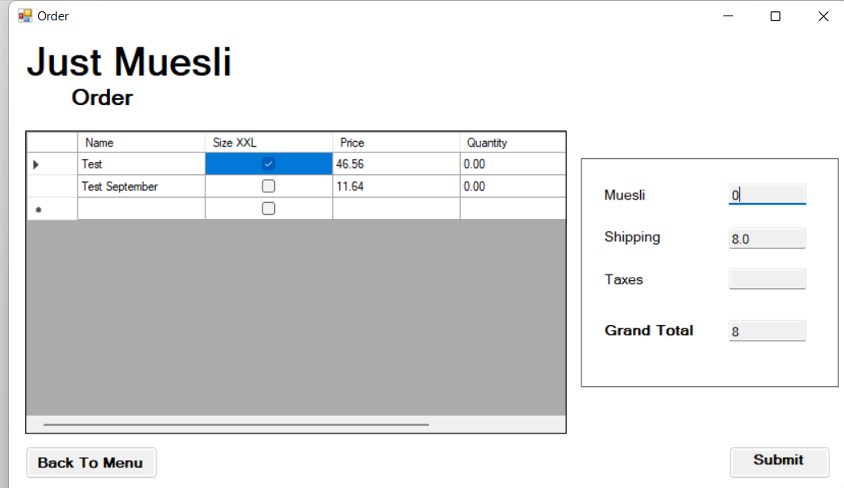

ANSWER: The Competitor has Scored Partial Marks (1.7) as:
- Missing corresponding tax value (no mark gain), all the other components and data are displayed correctly (Add 1.8) (Coloured in red did not add)
- An item (Muesli) is shown in the screen which is not requested by the requirement (deduct 0.1 marks)

Criteria F Testing

Criteria  ID | Sub  Criteria | Aspect Description | Extra Aspect  Description | Score | Max  Marks | Competitor work: (after demonstration)
F1 | Unit test | Implementation Unit Test | - Add 1.0 if login user tested  - Add 1.0 if retrieve user profile from the database tested | 1 | 2 | - A unit testing project is included in the Visual Studio Solution.  - Only login user tested with successful case

ANSWER: The Competitor has Scored Partial Marks (1)

